Task 3: The Alpine Docker Container

Step 1: Pull and Run the Alpine Image
To run the Alpine Image Docker Container, you can use the Docker run command.
sudo docker run -it alpine:3 or sudo docker pull alpine

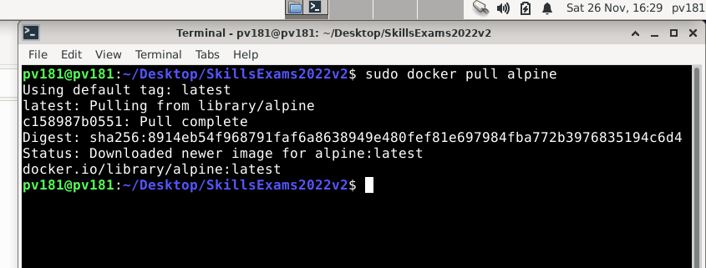

Step 2: Install Python 3
To install python 3 inside the Alpine Container, you can use the apk add command inside the shell.
apk add python3

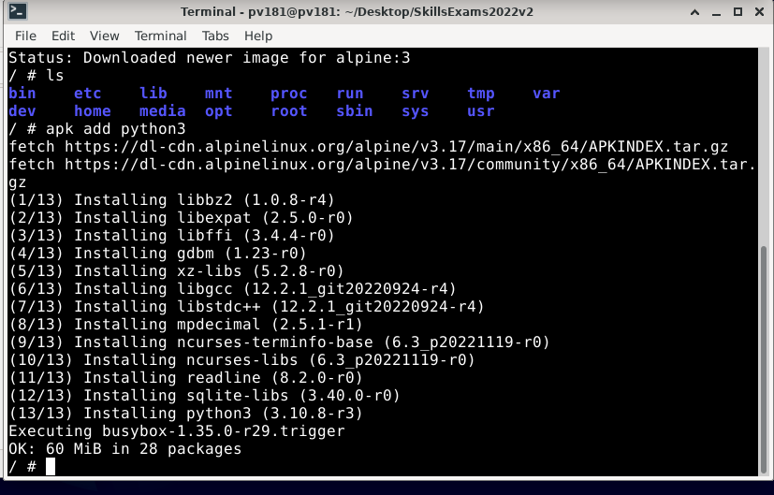
Step 4: Install Firefox
To install Firefox inside the Container, you can use the following command.
apk add firefox
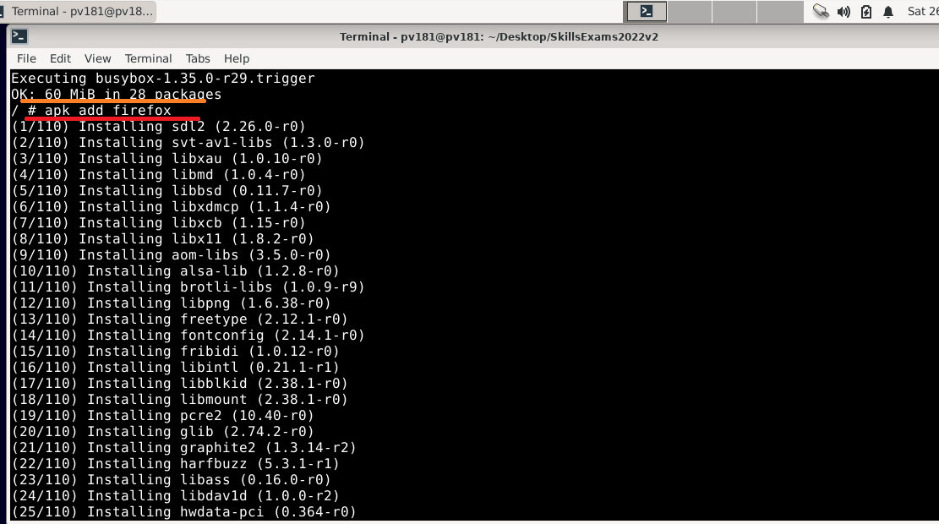
Step 5: verify by listing the images.
sudo docker images
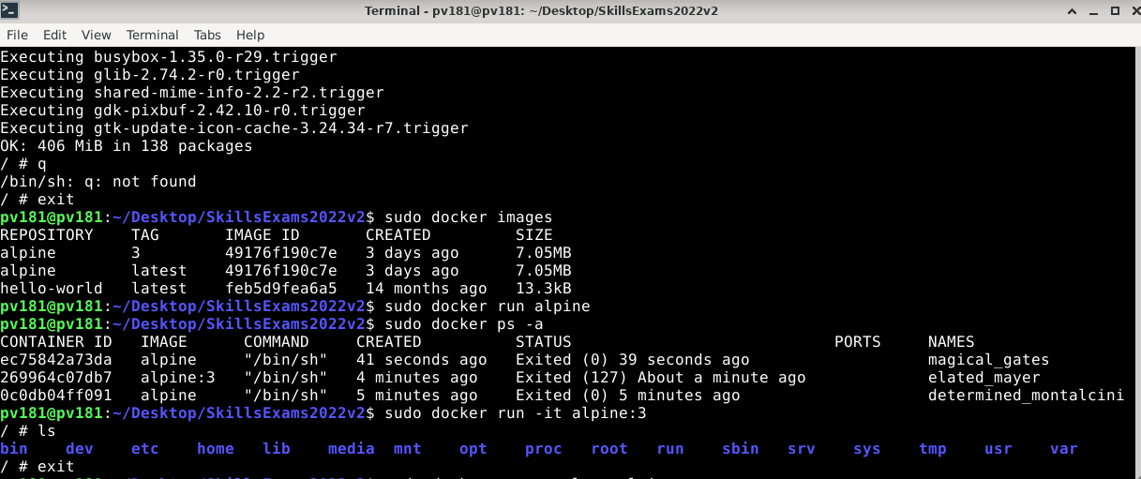

Showing alpine server as the latest Repository
